**Food Trend in Metro Manila, Philippines**

## Hermie Dalay

July 10, 2020

# Introduction

Filipinos fondness for eating-out accelerated the proliferation of food service businesses in the Philippines; from fast food chains, cafeterias, restaurants, and eat-all-you-can buffets especially in the big cities within Metro Manila. For the lack of general term and for simplicity, we will refer to all food service establishments as “restaurants” which include both sit-down establishments and fast-food outlets.

Metro Manila is composed of 16 big cities which includes Manila and the adjacent and nearby cities namely Makati, Taguig, Las Pinas, Paranaque, Mandaluyong, Malabon, Navotas, Caloocan, Pasay, Quezon City, Muntinlupa, Valenzuela, San Juan, Marikina, and Pasig.

There may be a lot of existing restaurants in the big cities in the Philippines and it may seem to be congested already, but with the right concept and correct location, there is still room for a new restaurant and may well be the next Jollibee or Starbucks.

## Problem

Starting a new restaurant is lucrative yet a tricky business venture. We often see an opening of a new coffee shop only to see them closing down after only a year or two. Some don’t even get to celebrate their 1st year anniversary. It is said that restaurant business is all about location, location, location. I agree, but one more thing is as important as the location, the CONCEPT. One can be at the best prime location in a big city, but with the wrong concept, success may not see fruition. Thus, finding the best location for the right food concept is important before venturing to a new food business.

## Objective

The objectives of this project is as follows:

1. To determine the most common restaurant themes, know the food trend in Metro Manila.
2. To determine the popular locations in each city of Metro Manila.

With the above objectives, we can give new entrepreneurs some insights on what are the existing trend in the food service business in Metro Manila and where are the popular locations. These insights can help them in their decision on what kind of restaurant to put-up and where are best location that kind of restaurant.

# Data

With this project, we will be extracting data utilizing Foursquare API to get business profiles and information of existing food service related businesses in the cities of Metro Manila in the Philippines. We will also be needing the geographical location of Metro Manila cities.

## Data Acquisition

* + 1. Geographical location data of cities in Metro Manila, Philippines

Due to the lack of readily and complete available data, I compiled available data from the internet and save the file as 'Cities_Towns_PH_Coordinates.csv’; a copy of which is available in IBM Cloud Object Storage. I kept all the information gathered for future use and reference. Getting the necessary information will be done through coding.

* + 1. Data of existing food service businesses in Metro Manila

Create venues dataframe, “manila_venues”; get the data of existing food service businesses in Metro Manila from Foursquare API. We will be extracting data of venues within 5 km radius from the city centers under the category “FOOD” with category id '4d4b7105d754a06374d81259'. The geographical locations of each city in Metro Manila will be extracted from the file 'Cities_Towns_PH_Coordinates.csv’.

## Methodology

* 1. Data examination and cleaning
     1. Locations

Below are the first five rows of the list of locations:

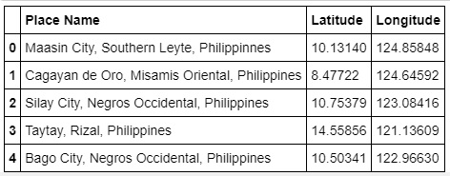

After some data examination and cleaning, we extracted the geographical locations of each city of Metro Manila.

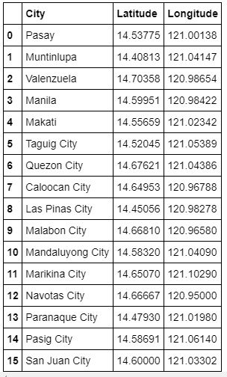

* + 1. Venues

Examining the data extracted from foursquare, “manila_venues”, we found that it has 1517 rows and 7 columns.

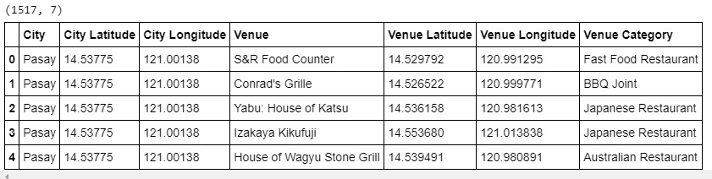

***Let’s see the breakdown of extracted venues for each city by grouping.***

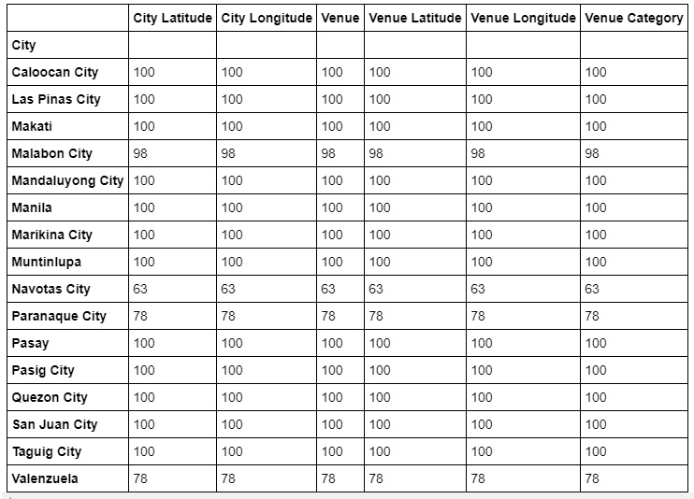

***There are 75 unique food categories in all.***

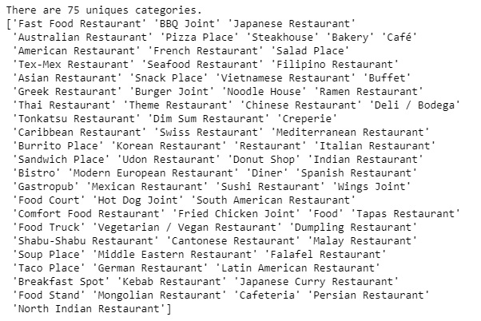

* 1. Plotting the location of the venues with folium

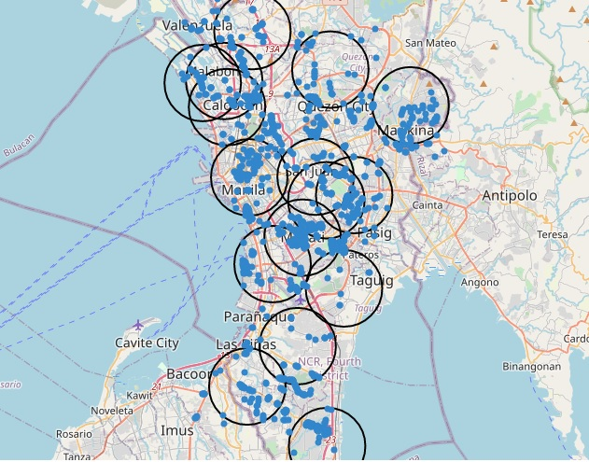

* 1. Exploratory data analysis.
     1. One hot encoding

Performed one hot encoding on dataframe “manila_venue” to convert the categorical data ‘Venue Category’ to integer data for use in the clustering. Named the new dataframe “manila_onehot”.

* + 1. Data wrangling and simplification

Summarized the data by grouping by “City”, and get the sum of each Category. Simplified the data by combining similar and related categories in column “Category” then dropped the combined categories. Categories food, food cart, food truck, and food court were also dropped as they have no specific identifying category.

* + 1. K-means clustering

Done k-means clustering to segmentation and cluster the existing restaurants in the cities in Metro Manila. Clustering will allow us to create a greater efficiency in categorizing the data into specific segments.

1. Results

After all the data wrangling and simplifications, here are the results.

* 1. Top 20 restaurants category in Metro Manila

At number one, not surprising, in the list is Fast Food Restaurants. The sustained positive growth of the industry during the last decade can be attributed to the robust performance of the restaurant sector, particularly the fast food subsector given that approximately 80 percent of the restaurants in the country are classified as fast food. Based on the report released by the Department of Primary Industries- Victoria, Australia, the Philippines Fast Food subsector is valued at USD 3 billion, with growth ranging from 10% to 15% in the last decade.

At number two is Coffee Shops. This is quite interesting because it is only the last five years or so that we’ve seen the emergence of coffee shops. This can be attributed to the fast growth of the BPO industry.

Asian restaurants are still strong led by Chinese restaurants and Japanese restaurants. Filipino restaurants are in top 5, this shows that Overseas Filipino Worker or OFWs are still one of the main driver of the food service industry.

**Top 20 restaurants in the whole Metro Manila area:**

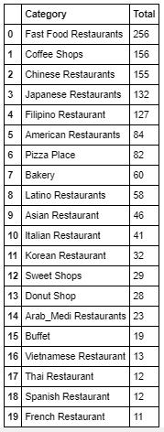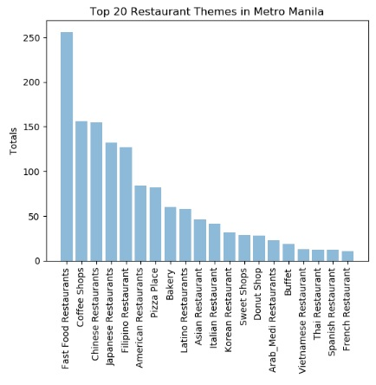

**Checking the top 10 venues for each city.**

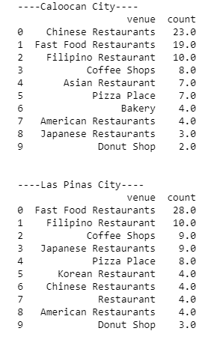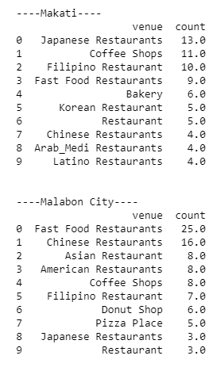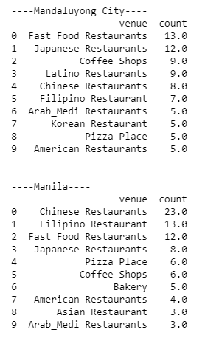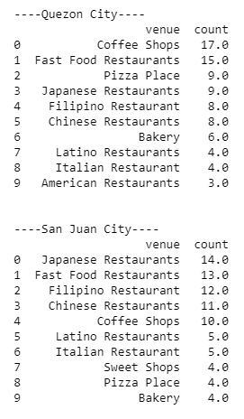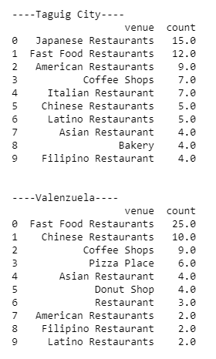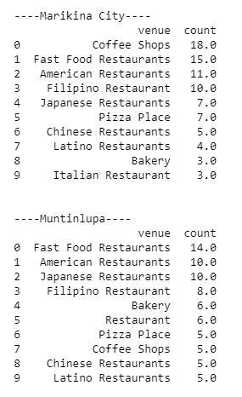

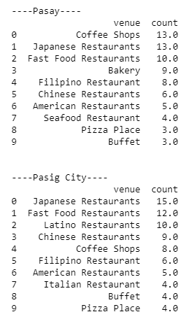

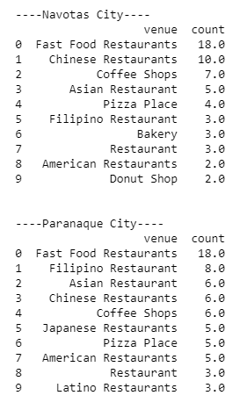

**Top 10 Restaurant by City**

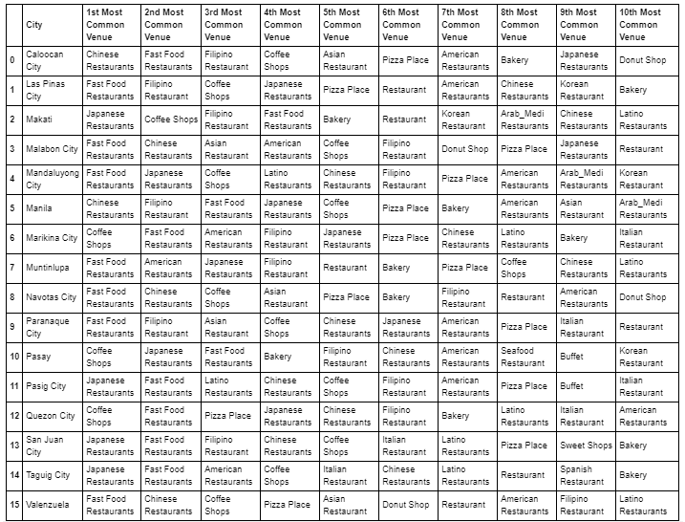

Top 10 Most Common Venues with Clustering

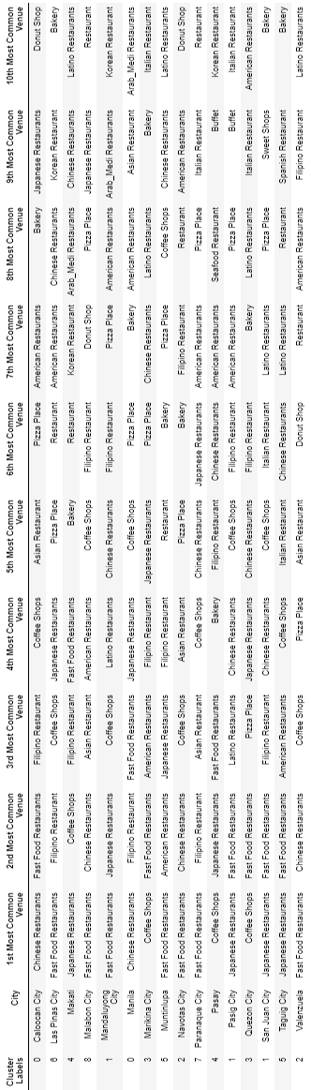

**Map of clustered cities**

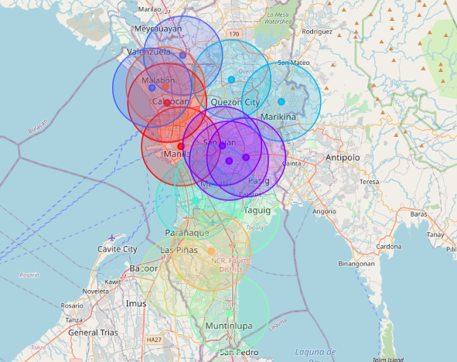

1. Discussion
   1. Observations

Overall, based from the results, it is evident that the trend in food service is fast food restaurants. Far second and third are coffee shops and Chinese restaurants accordingly. In cities with well-established business centers where there is a big presence BPOs like Makati, Mandaluyong, Pasay, San Juan, and Taguig, Japanese restaurants and Coffee shops are more common.

In cities in the northwestern part of Metro Manila, Caloocan, Malabon, Manila, Navotas, and Velenzuela, Chinese restaurants are still the king. This is understandable because the Chinese communities are concentrated on these areas as well as their businesses. It is important to note that China Town is located in Manila.

Filipino restaurants are prevalent in Paranaque and Manila cities where the main international airports are situated.

The category to watch is the Buffet restaurants which is at number 16. Few years back, these type of restaurants are relatively non-existent. Now, they are all over the Metro Manila.

* 1. Recommendations

Based from the results, here are guidelines that can help anyone who is planning to start a new food service business in Metro Manila.

* If venturing in a fast food restaurant, any place in Metro Manila is a good location.
* Japanese restaurants and coffee shops are more welcomed in Makati, Mandaluyong, Pasay, San Juan, and Taguig City.
* More traditional restaurants like Filipino restaurants and Chinese restaurants have a good following in Manila, Caloocan, Malabon, Navotas, and Velenzuela.

1. Conclusion

In conclusion, fast food restaurants are the most common category of food service business in the whole Metro Manila. Other categories are strong in some cities but weak in others. So, it is important to know what category is more appropriate in certain city.

*Disclaimer:*

*This project was prepared as a requirement in the completion of my data science course Applied Data Science Capstone from Coursera. Reader can use any Information, data, and recommendation at their own discretion. The author will not be responsible for any damage and/loss the reader may incur in the use of any information from this report.*

*To God be all the Glory and Praise!*

--- end of report ----